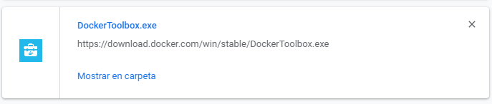

<https://download.docker.com/win/stable/DockerToolbox.exe>

Important run comand for run publis diferent instances of imagenes in diferents ports

$ docker run -d --name Instace3 -p 90:90 -p 23:23 jenkins

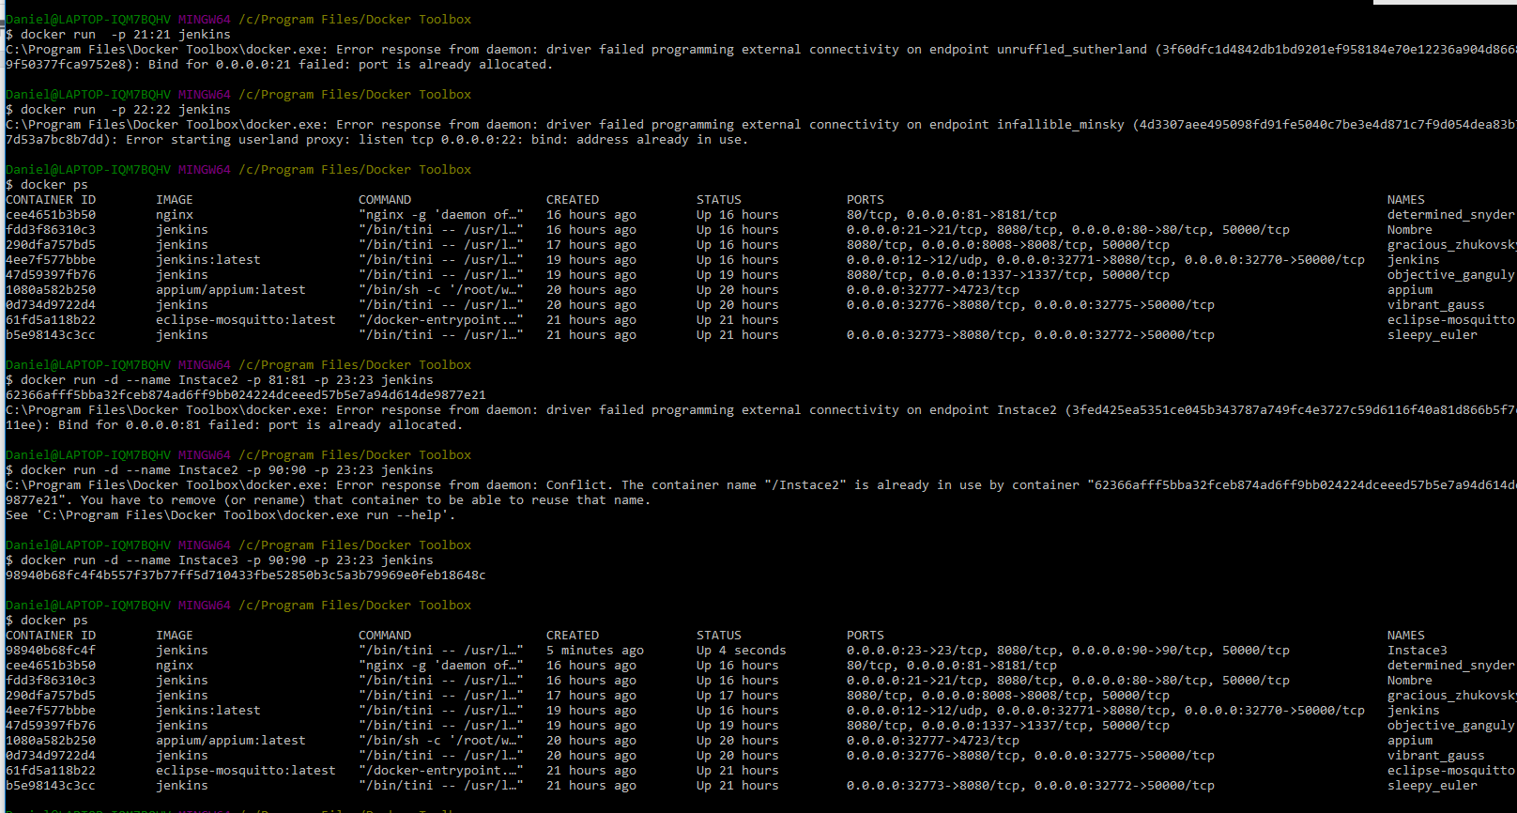

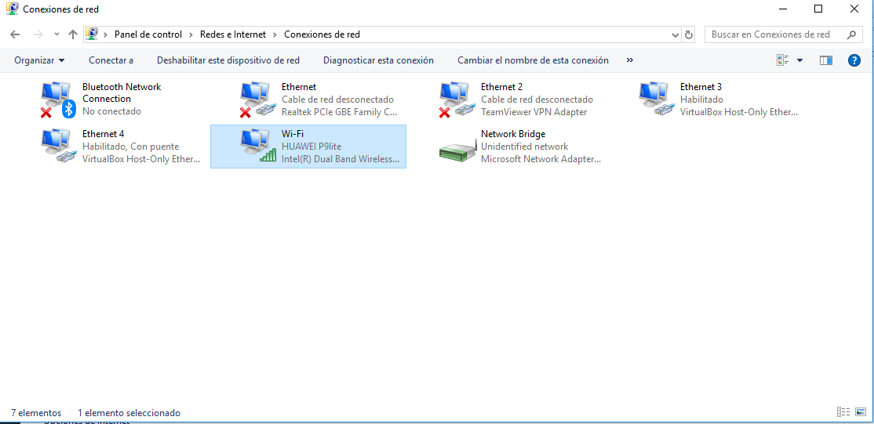

Agregate brigde this

Review all sethig

